**Tracing the Growth of the Global Community: A Population Forecasting Analysis**

**1.INTRODUCTION:**

**Overview:**

Population projection gives a picture of what the future size and structure of the population .

By sex and age might look like. It is based on knowledge of the past trends, and, for the future, on assumptions made for three components: Fertility, mortality and migration.

**The Need For Forecasting Population**

In the solution of any planning problem, the planner either makes an explicit forecast, or makes some implicit assumption about the population for which he is planning. "Population" includes more than mere numbers is people. The planner must know what kind of people live in his planning area, what types of lives they lead, and would like to lead, how long they will live, and how long they will reside in the particular area; and who will replace them when they move out or die; how many children they will have (and would like to have under different conditions), whether these children will live in the area, and many other factors.

Many communities have installed facilities which have become useless because predicated on faulty estimates of future population, or they have failed to install facilities where justified by future population. A common example of such errors is the newly constructed school in an area where the population is aging rather than being replaced by young, child-bearing families. Sewer systems have been expensively developed only to be later replaced because the population soon was double or triple what was anticipated for the area. Narrow streets have been later widened at great expense. On the other hand, land often has been overly zoned for commercial purpose in the expectation of a vast increase in population which did not materialize. Or land was zoned for potential capacities in some cities in some cities of whole states many of our communities today.

**STRUCTURE OF A POPULATION FORECASTING**

Population forecasting is defined as the method of determining the expected population for a particular design period of a water supply system with the help of the study and analysis of future events and available records.

The population is an important parameter that is determined for the design of the water system of a particular area. Water supply systems are designed for a population expected for a certain design period instead consideration the present population of the area.

ere are mathematical methods that can be used to determine the population for a design period.

**PROBLEM DEFINITION & DESIGN THINKING**

**2.1 EMPATHY MAP:**

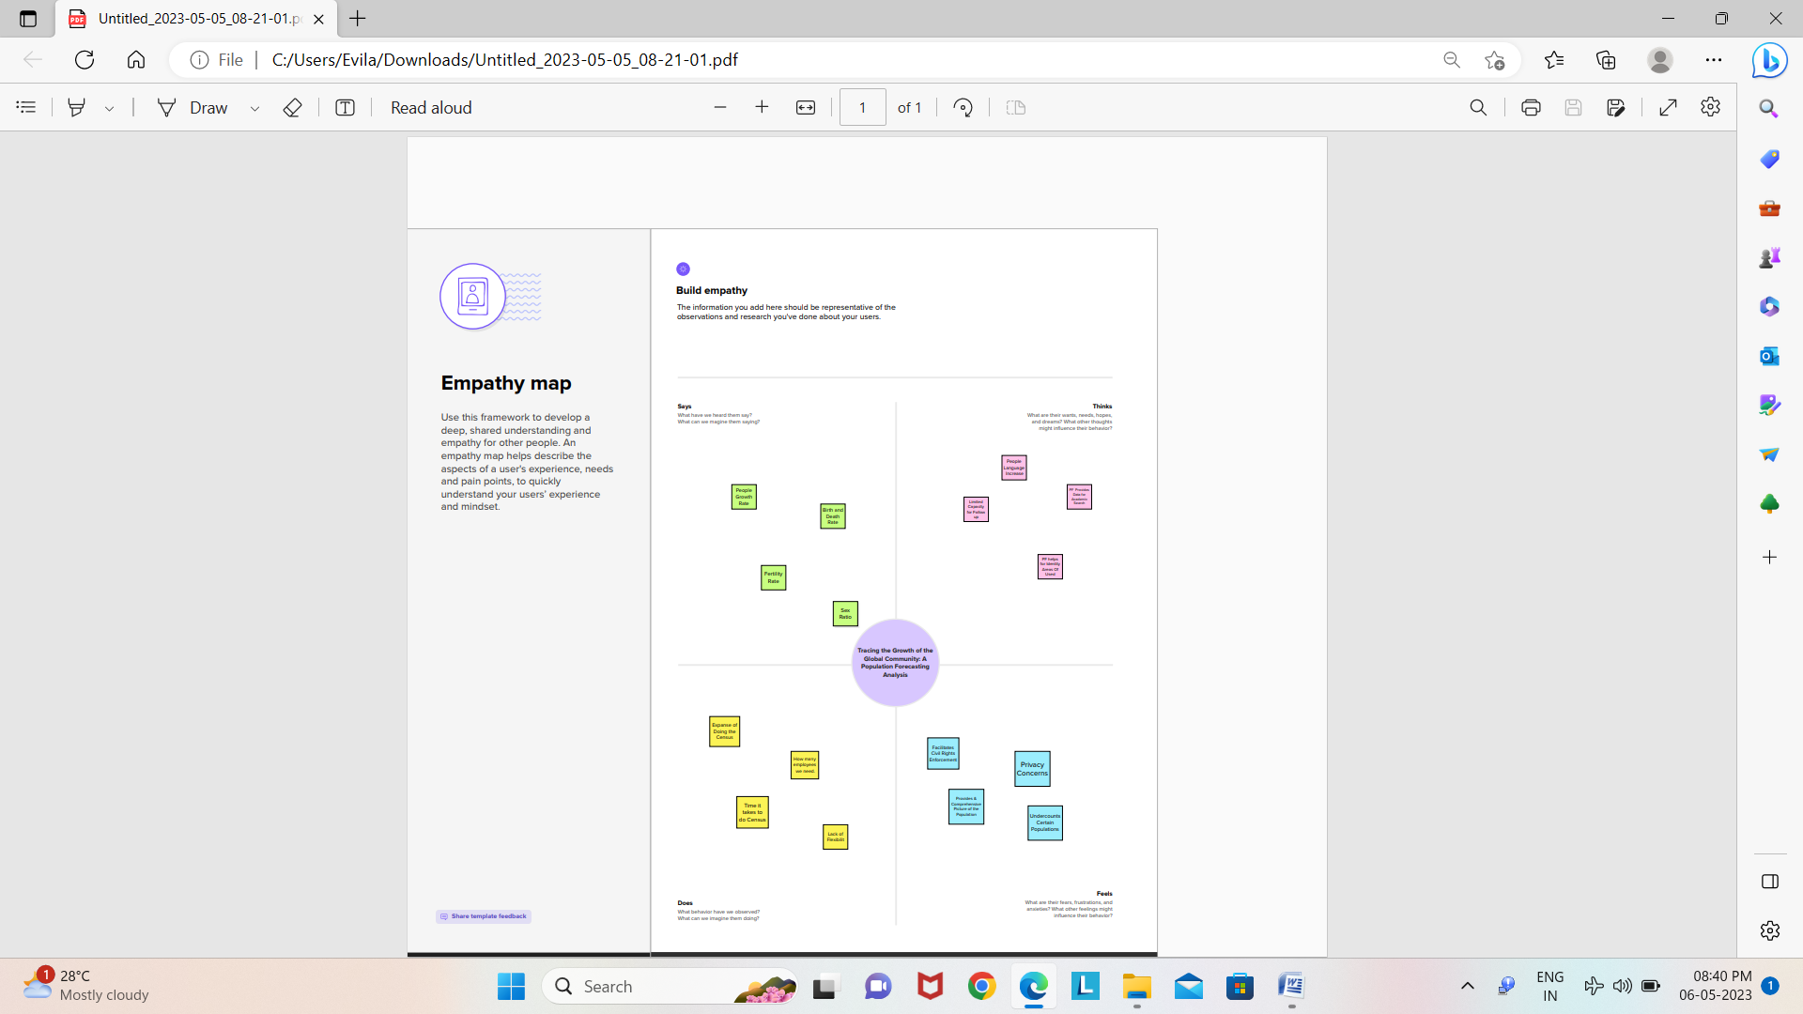

**IDEATION & BRAINSTROMING**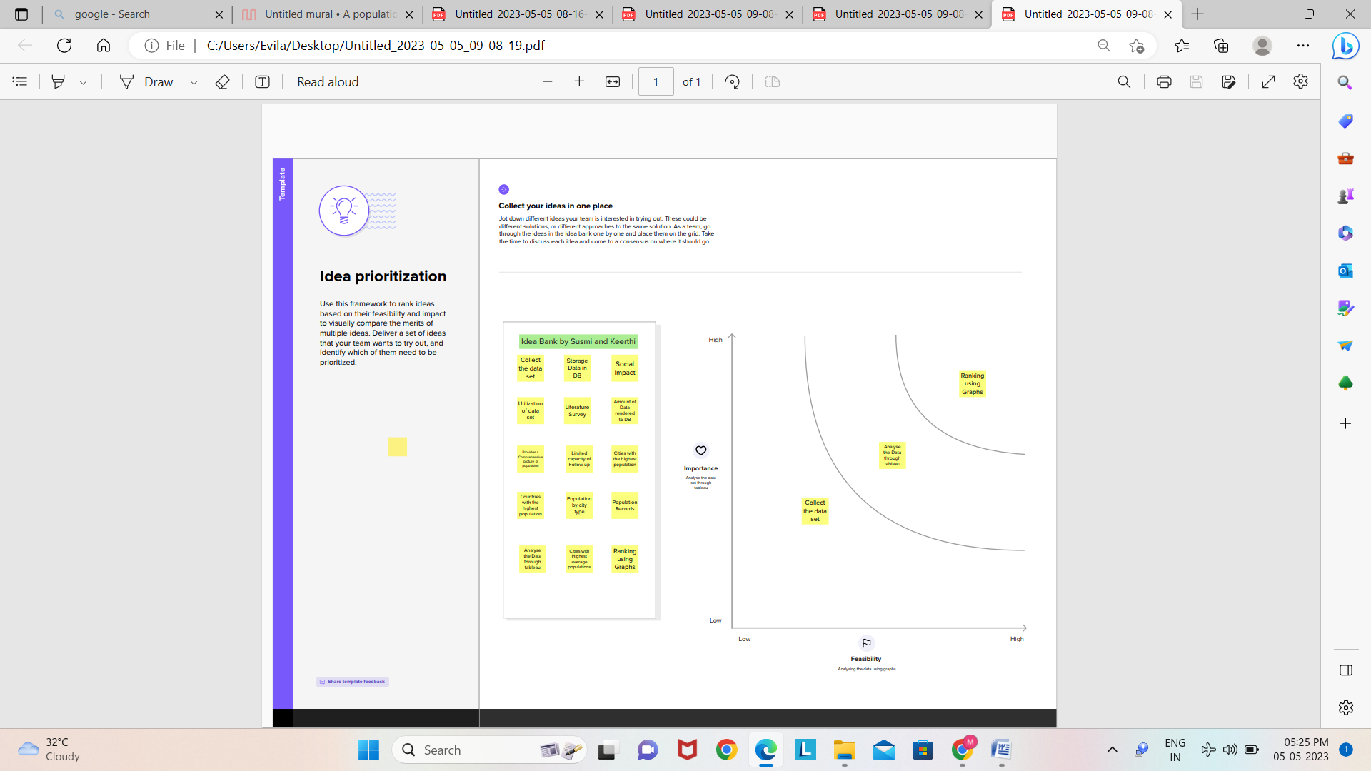

**3. RESULT**

**Data Source**

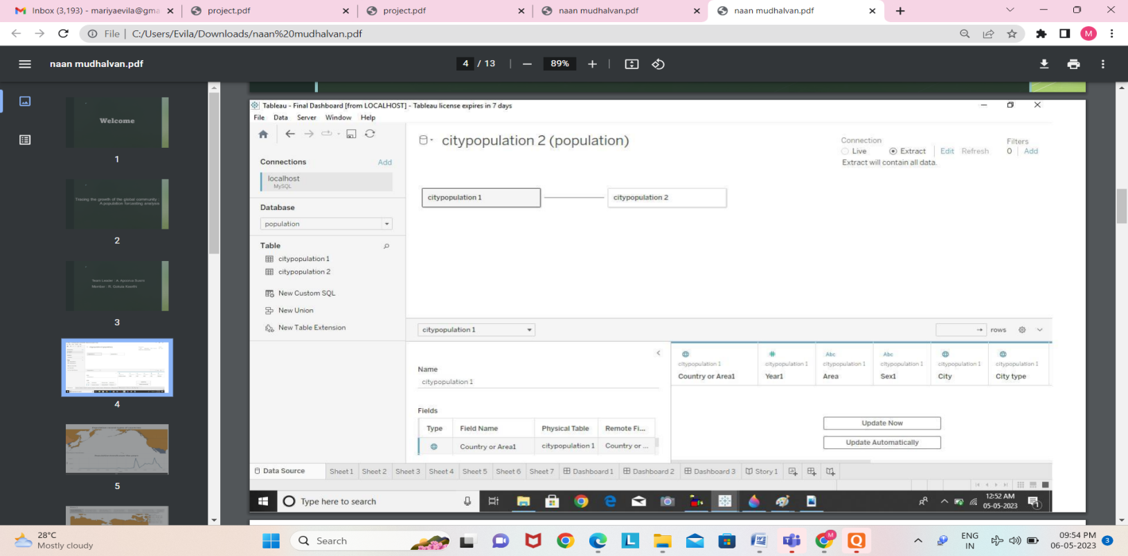

**Dashboard**

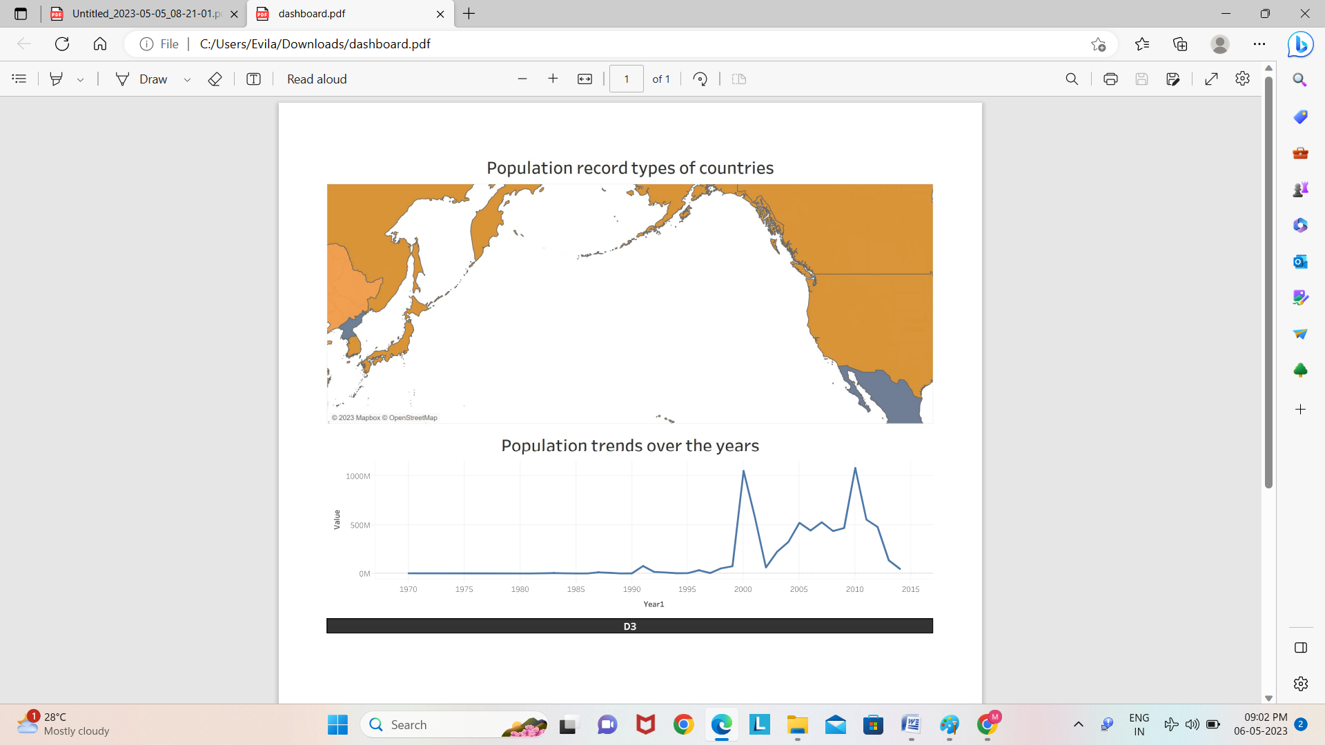

**Story**

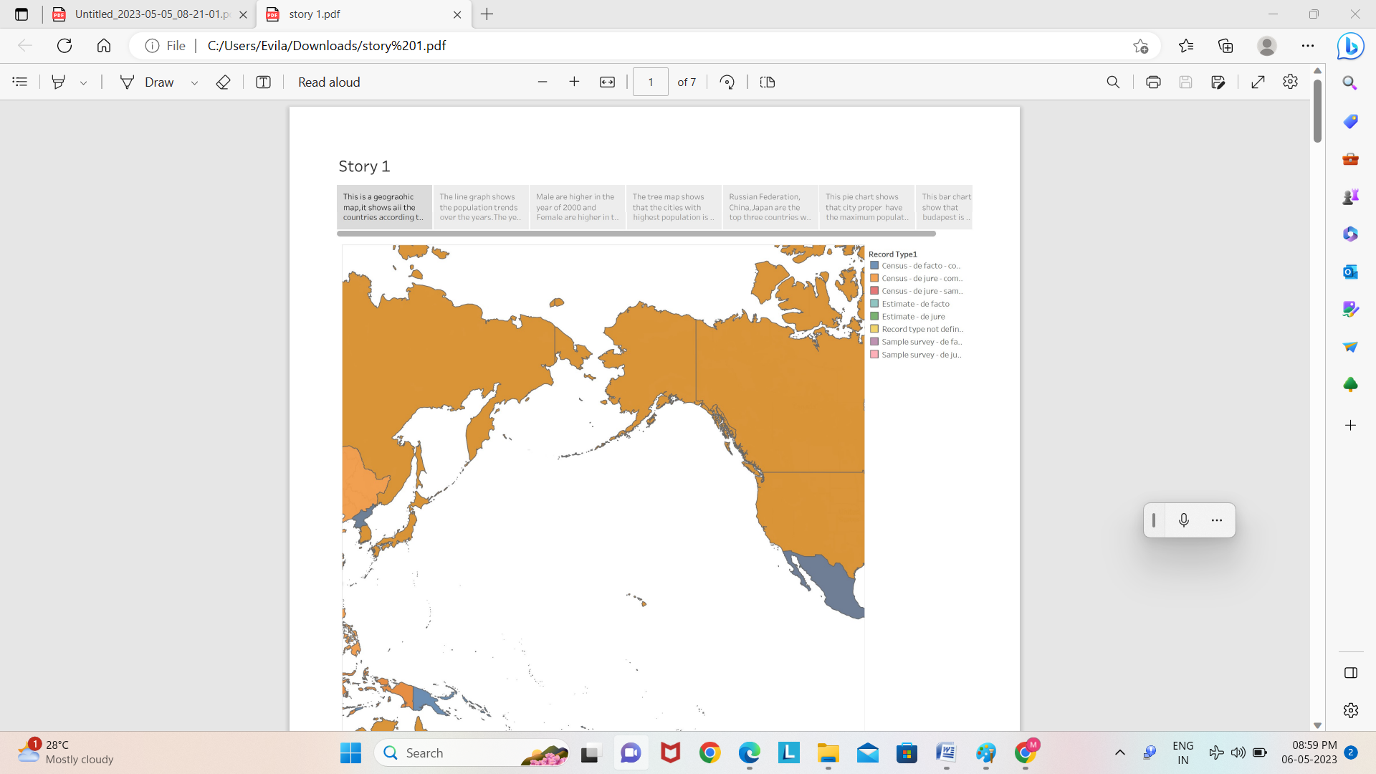

**4. ADVANTAGES AND DISADVANTAGES**

The advantages pertaining to forecasting include the following:

**Insight Creation** - Gaining insight is a must for operations that are seeking to generate adequate forecasts. Forecasting gets you into the habit of looking at the past and real-time data to predict future demand. While doing this, you will be able to anticipate demand fluctuations more effectively. It also will provide insight into your company's supply chain health and provide you with an opportunity to make any corrections or adjustments based off of new information that is received through real-time data.

**Learning From Past Mistakes**- Forecasting also enables you to make decisions based off of past errors and could provide insight on how to correct these in the future. You don't start from scratch after each forecast. Even if your prediction was nowhere close to what ended up coming to pass, it provides a starting point. It is common to review where and why things didn't happen the way you had predicted and you should be able to see an improvement in your forecasts. You will also get into the habit of reflecting upon past performance as a whole.

• **Cost Decrease** - Cost decrease is another substantial factor within manufacturing operations considering that forecasting can reduce the amount of errors due to following a schedule based off of the past. Anticipating demand will aid you with tweaking your processes to increase efficiency all along the supply chain. Because you are able to predict what customers will want and when they'll want it, you will ultimately be able to decrease excess inventory levels and increase overall profitability.

**It can be Time-consuming and Resource-Intensiv**e - Forecasting pertains to data gathering, data organizing, and coordination. Companies will employ a team of demand planners who are responsible for coming up with the forecast. In order to adequately conduct this function, demand planners will need a substantial amount of input from sales and marketing teams. It is also not uncommon for process to be manual and labor-intensive, which will ultimately take up a lot of time. If you have the correct technology in the right place, it is much less of an issue.

The disadvantages pertaining to forecasting include the following:

**Forecasts are Never Completely Accurate** - Forecasts are never 100% and it is almost impossible to predict the future with certainty. Even if you have a great process in place and forecasting experts on your payroll, your forecasts will never be spot on. Some products and markets will have a high level of volatility, especially during times of crisis. The coronavirus has definitely enhanced and increased this volatility within the market - which is why understanding what factors influence your demand can potentially aid with developing forecasts during this time. Having said that, the main drawback of forecasts are that they are almost always wrong - which leads to excess or shortage of inventory.

**Could be costly** - Forecasting can be extremely costly especially if it is done right. If you want adequate and close-to-accurate forecast, you have to spend the money, time, and resources to do so. Hiring a team of demand planners is a significant investment and adds to the cost of utilizing quality tools. While it is costly, you should easily see a return on this investment over time and your forecast should be much more accurate, thus saving you money and paying for itself in the long run.

**5.APPLICATION**

It allow a better understanding of how complex interactions and processes work. Modeling of dynamic interactions in nature can provide a manageable way of understanding how numbers change over time or in relation to each other. Many patterns can be noticed by using population modeling as a tool.

It is concerned with the changes in parameters such as population size and age distribution within a population. This might be due to interactions with the environment, individuals of their own species, or other species.

Population models are used to determine maximum harvest for agriculturists, to understand the dynamics of biological invasions, and for environmental conservation. Population models are also used to understand the spread of parasites, viruses, and disease.

**6.CONCLUSION**

It cannot be over-emphasized that there are many varied factors influencing birth rates, migrations, and to a lesser degree, death rates. Unfortunately, much of the research necessary to isolate these various factors and to appraise their effects remains to be done. The planner in forecasting future population for his area may seek the aid of a demographer especially trained in the technical study of population.